***Day 4 - Dynamic Frontend Components – Comforty***

**Overview:**

Comforty is a fully functional e-commerce platform focused on selling chairs, developed using Next.js, Sanity, and Tailwind CSS. It offers a seamless shopping experience with features like a product catalog, detailed product pages, shopping cart, and secure checkout. The platform is responsive, ensuring smooth performance across devices. With an intuitive interface and fast load times, Comforty delivers a modern, user-friendly solution for purchasing chairs online.

1. **Functional Deliverables:**

* Product Listing with Dynamic Data:

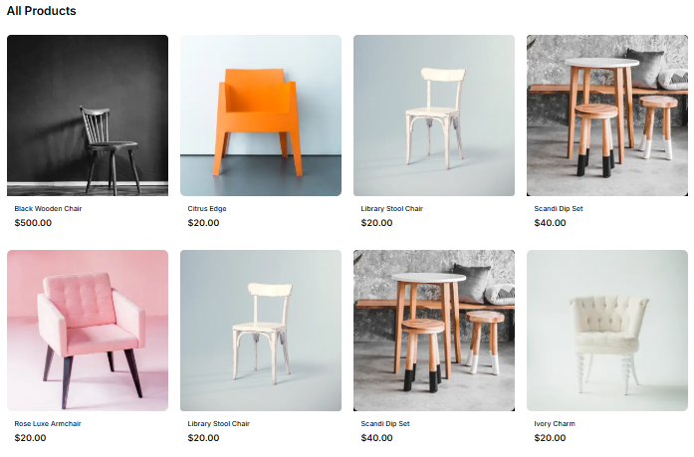

* Product Detail Page:



* Category Filter:

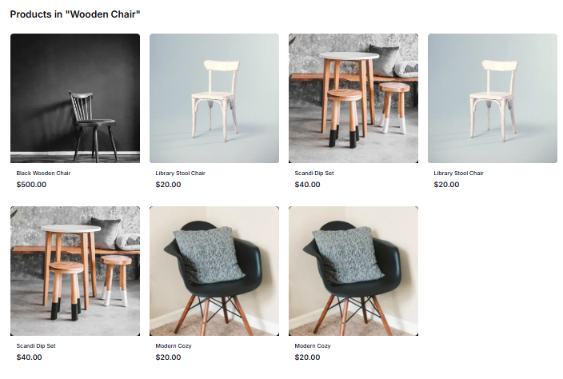

* Related Products:



* FAQS:

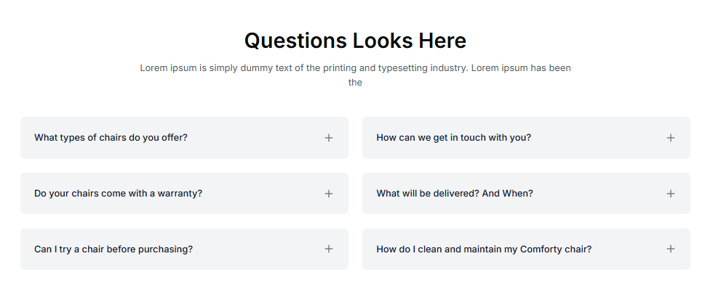



* 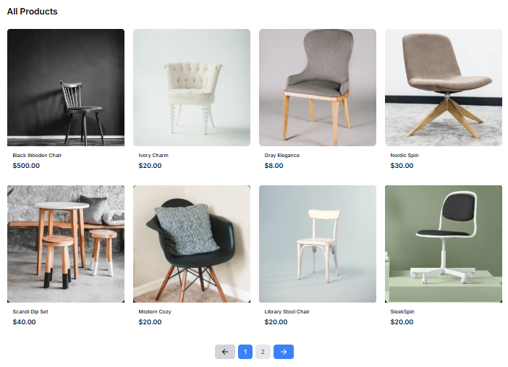Pagination:
* NewsLetter Section:



1. **Code Deliverable:**

* 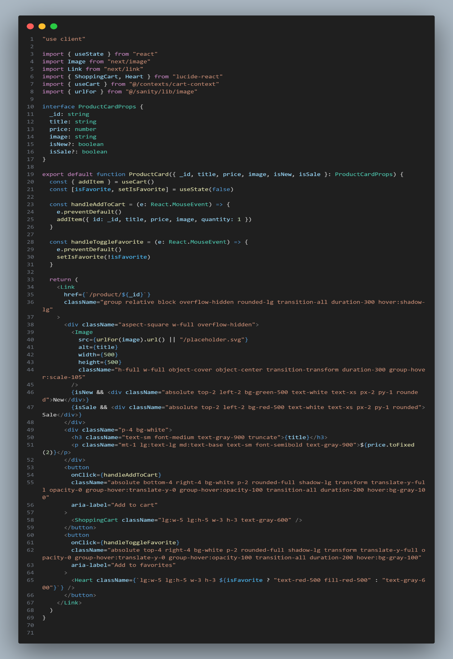Product Card:
* Products Page:

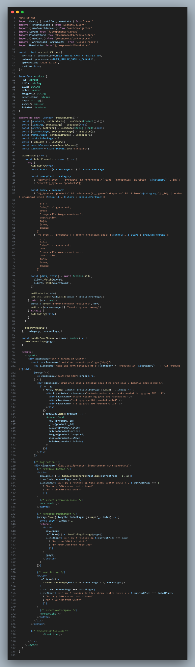

* Products Detail Page:

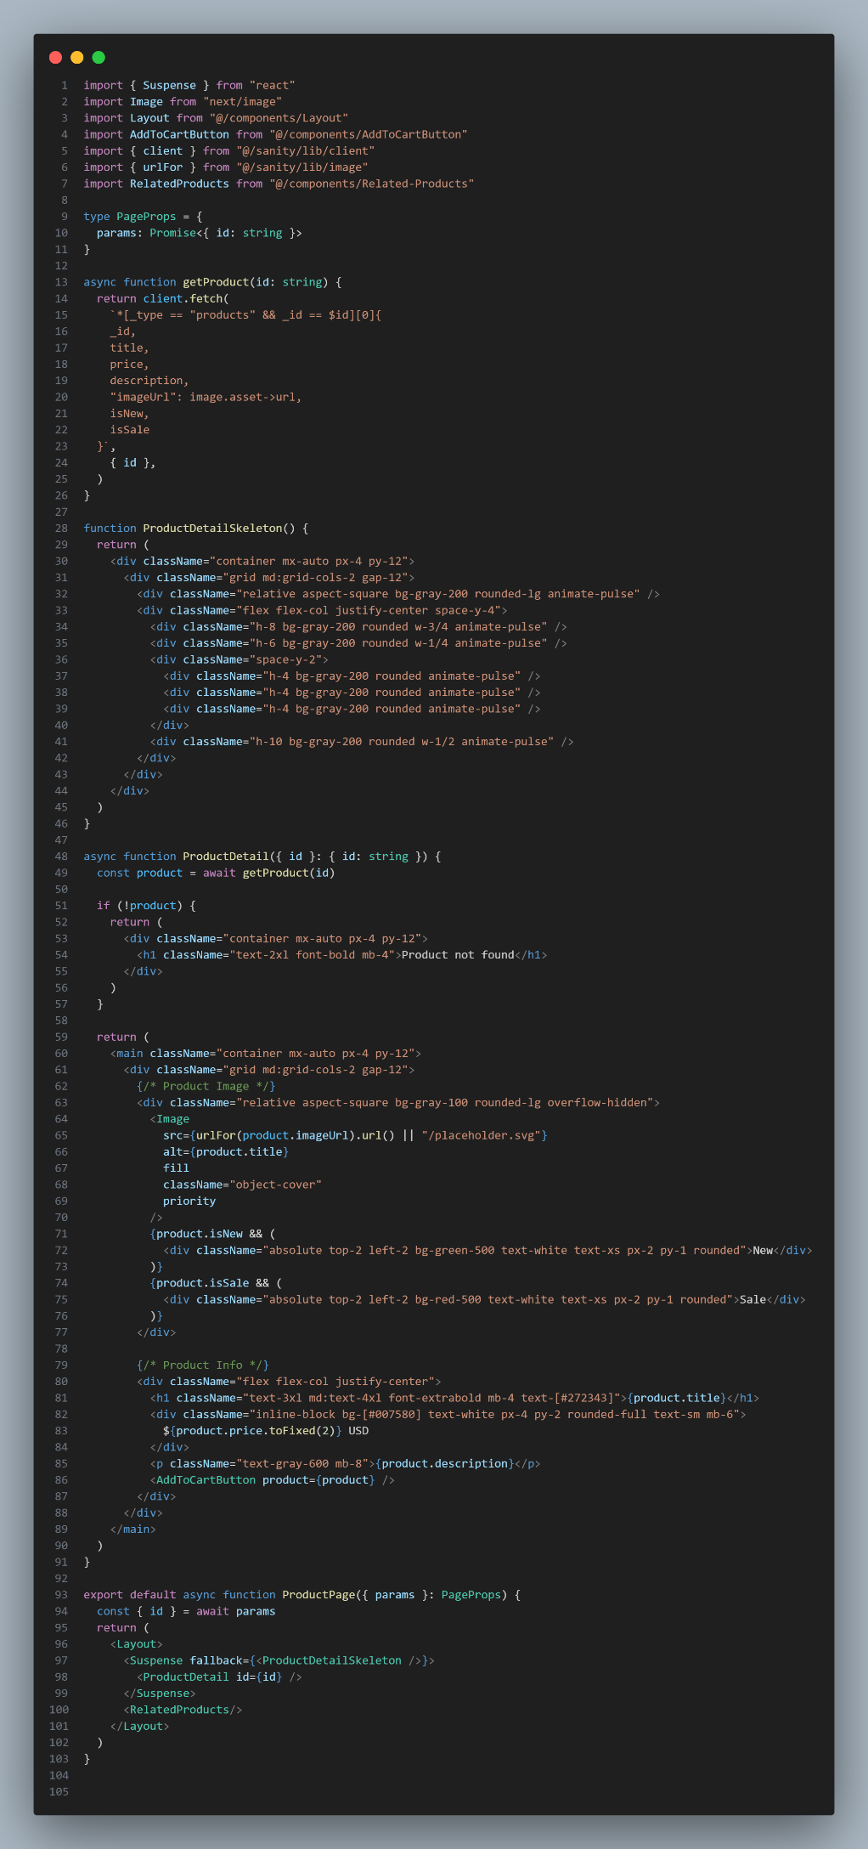

1. **Documentation:**

* ***Steps taken to build and integrate components:***
  + **Tech Stack**: Chose React.js, Node.js/Express, and MongoDB.
  + **Design**: Created wireframes in Figma.
  + **Frontend**: Built React components and used Material-UI.
  + **Backend**: Developed APIs with Node.js, Passport.js for auth, JWT for secure login.
  + **API Integration**: Integrated third-party APIs and tested them.
  + **Database**: Used MongoDB for user data storage and validation.
  + **Testing**: Conducted unit tests and manual testing.
  + **Deployment**: Deployed on Heroku/AWS (backend) and Netlify (frontend).
  + **Optimization**: Improved performance and UI.
* ***Challenges faced and solutions implemented:***
* During the Comforty hackathon, I faced challenges with UI design, API integration, and performance. I used Figma, AI, and friend input to refine the UI, debugged APIs with Postman, and solved issues through research. I optimized the database and performance, with AI suggestions, and resolved deployment issues on Vercel. Most challenges were tackled independently, with minimal help.
* ***Best practices followed during development:***

I followed best practices such as writing modular code, using Git for version control, documenting key sections, ensuring mobile-friendly design, and implementing robust error handling, optimized performance, and set up Vercel for smooth deployment, all while using an iterative development approach.